DDoS PROTECTION SYSTEM FOR CLOUD USING AWS AND MACHINE LEARNING

A MAJOR PROJECT REPORT

*Submitted by*

Shaurya Singh Srinet [RA2111032010006] Shounak Chandra [RA2111032010026] Charvi Jain [RA2111047010113]

*Under the Guidance of*

Dr. Balaji Srikaanth P.

(Assistant Professor, Department of Networking and Communications)

*partial fulfillment of the requirements for the degree of*

BACHELOR OF TECHNOLOGY

in

COMPUTER SCIENCE AND ENGINEERING

WITH SPECIALIZATION IN INETERNET OF THINGS

&

BACHELOR OF TECHNOLOGY

in

ARTIFICIAL INTELLIGENCE

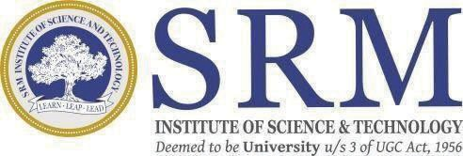

DEPARTMENT OF NETWORKING AND COMMUNICATIONS

SCHOOL OF COMPUTING

COLLEGE OF ENGINEERING AND TECHNOLOGY

SRM INSTITUTE OF SCIENCE ANDTECHNOLOGY KATTANKULATHUR- 603 203

FEB 2024